WEBEOC APPLICATION DETAIL INFORMATION

SAVE MY CHANGES TO GIT HUB.

IRINA

APPLICATION NAME: WebEOC

APPLICATION TYPE: Internal WEB Application for DeKalb County

APPLICATION WebEOC CURRENT VERSION NUMBER: 8.6.2.11

APPLICATION DESCRIPTION: WebEOC application used by DEMA (Dekalb Emergency Management) Department. This is NOT daily used application. Application does not linked to CAD. WebEOC is a web-based information management system that provides a single access point for the collection and dissemination of emergency or event-related information. WebEOC provides real-time information as provided by the users and can be used during the planning, mitigation, response and recovery phases of any emergency. The system allows for sharing of information in a variety of ways including document sharing, photo uploading, and displays for map and other GIS information. The system is customizable and flexible based on the users' needs.

VENDOR NAME: JUVARE

VENDOR SUPPORT SITE: <https://www.juvare.com/support/>

NOTE: According to Michelle Vernon DeKalb County has a support contract. To create a ticket user has first register with support site (see pic below)

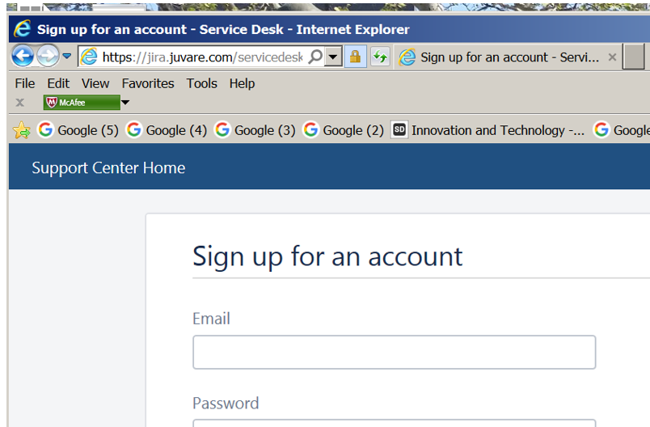

URL for WebEOC application: <https://eoc.dekalbcountyga.gov/eoc7/>

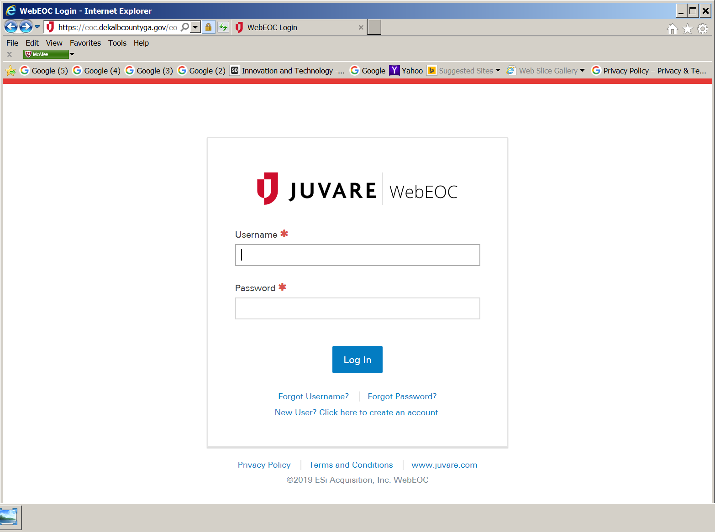

Dekalb County DEMA Sys Admin for WebEOC: Cary Hollis [chollis@dekalbcountyga.gov](mailto:chollis@dekalbcountyga.gov)

DEMA Sys Admin responsibilities: Responsible for day to day ongoing activities, creation of user accounts, groups, any application configurations within WEBEOC conducting software updates

* Create user’s account
* Support Application functionalities
* Open up a ticket with Vendor if Application Functionalities are not working
* Install WEBEOC VERSION Upgrades on Application Servers
* Test WebEOC application via Monthly Maintenance. NOTE: Michelle Vernon should add WebECO Admin to email notification for Monthly Maintenance.

DEMA GROUP Account in WebEOC Application: WEBEOCAdministrator.

ROLE: This is FULL Rights Account, what will never be lock.

NOTE: Cary Hollis has a ROLE as FULL Rights Account.

JUDICIAL GROUP SUPPORT

Description of Support: Judicial Group is serving as POC for WebEOC application.

Responsibilities include:  
 - if user open up a ticket that application site is down open: up a ticket with Server Group; they have

to check if SERVERS are up and SERVICE is up and running.

* If user open up a ticket that he/she is not able to login to application: open up a ticket with DBA group to be sure that database is up and running
* If servers are up and service is up but application is not running: open up a ticket with Juvare vendor
* If user open up a ticket that WebEOC Functionalities not working: reassign ticket to DEMA Sys Admin
* Test WebEOC Application via Monthly Maintenance (NOTE: It should be done also by DEMA Sys Admin)

Name of POC: Irina Gindina

NOTE: For now, at October 7, 2019 Judicial group does not have access to application’s Production Servers. I am not sure if we ever will get an access (see pic below)

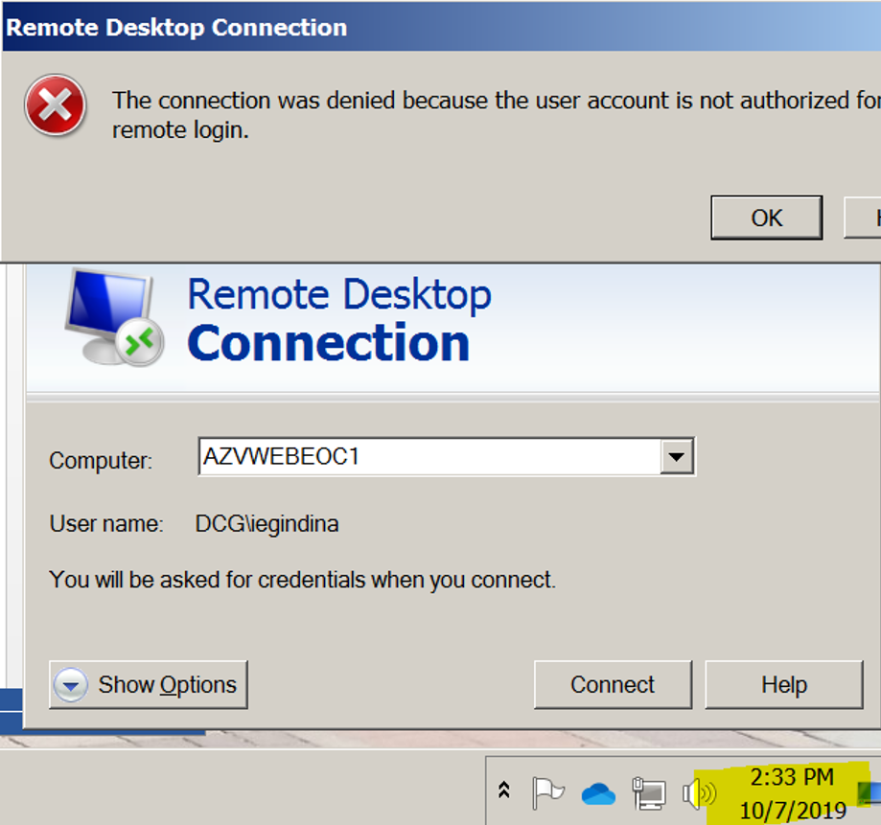

My understanding we have to open a ticket with Server Group to check if Prod app servers are up and running.

SERVER GROUP SUPPORT

Description of Support: Server Support

Responsibilities include:

* run Monthly Maintenance Window Security update on PROD servers. Check that Pull Service is up and running after update had been done.
* when ticket has been open by DEMA or Judicial Group: Check if PROD servers are up and running

Name of person: Chen Weidong; Yancy LeCroy

DBA GROUP SUPPORT

Description of Support: Data Base support

Responsibilities include:

* Support database connection to Application
* Perfume database backup and Maintenance according to Plan below

Backup  Full Backup (daily)

Backup - Transaction Logs (every 30 minutes)

Check database integrity (weekly)

Reorganize index (weekly)

Update statistics (weekly)

Shrink database (weekly)

Rebuild index (weekly)

Maintenance cleanup (weekly)

Name Of person: Gene Shvartsman

VENDOR SUPPORT

Description of Support: Michelle Vernon stated that DeKalb County has an Agreement for Vendor Production Support. We have a link to Juvare Support site. Any group will open up a ticket with Vendor.

Responsibilities included:

* Send an email with New Release Notes
* Provide new Version’s Upgrade
* Provide Bug Fixes upgrade
* Provide Functionalities support for DEMA group

VERSION’s UPGRADE and BUG FIXES PATCHES PROCESS

For now, at October 4, 2019 there is no information who have to run Version’s Upgrade and Bug Fixes patches on PROD Applications servers.

Michelle Vernon said she will call a meeting with Felicia Green, Lashawn Reeves and Steven Tylor to define what group will be responsible for upgrade.

DEMA group’s Sys Admins stated on the on-site production installation meeting they do not have a resources to participate in upgrade process.

PRODUCTION ENVIRONMENT INFRASTRACTURE

Environment was created nd Installation was run by vendor representative Paul Menson.

He installed executable and also provide direction to Weidong Chen and Gene Shvartsman.

Date of On-Site Installation Meeting: October 2, 2109.

PRODUCTION SERVERS NAME:

* AZVWEBEOC1
* AZWEBEOC2
* DMZ server for accessing WebEOC application from outside of Firewall (like accessing email or Kronos)

PRODUCTION SERVER LOCATION: AZURE

PRODUCTION SERVERS INFASTRACURE SCHEMA DESCRIPTION:

There are three servers: two Production Application servers and one DMZ server.

Both Production Servers are located on Azure. They have two different IP addresses and stay BEHIND the Load balancer.

Application pointed to Load balancer IP Address and Load balancer redirect Application either to AZVWEBEOC1 or AZVWEBEOC2. Its usual practice for Load Balancer Method.

DMZ server using when user login to application from outside of Dekalb County.

WHO WILL HAVE AN ACCESS TO PRODUCTION SERVERS:  
 - Dekalb Server Group

* Dekalb DBA
* Dekalb Judicial Application Group (no access at October 7, 2019)
* Vendor

WHAT WILL BE RUN ON PRODUCTION SERVERS

* Maintenance Window Security update

Responsible: Dekalb Server Group

* Application ‘s version upgrade and Bug fixes patches

Respnsible: Vendor will send Release Note, new executable and detail instruction. For now, At October 4, 2019 there is no clarification what group is responsible to run upgrade. Michelle Vernon should call a meeting and appointed who will run upgrade and fixes.

* Security updates

Responsible: Vendor

PRODUCTION SERVICE NAME: Pull Service

PRODUCTION SERVICE LOCATION: AZVWEBEOC1, AZVWEBEOC2

SERVICE DESRIPTION: Connect application with Database.

PRODUCTION SERVICE MAINTENECE: This is automatic Service. Server Group should verified that this Service is up and running via Monthly Maintenance update.

NOTE: Also, Pull Service should be stop and restart via Version’s upgrade, but I am not sure.

HOW TO ACCESS PROD SERVICE: Login to PROD Server AZVWEBEOC1 or AZVWEBEOC2 -> Open Service Management Console

PRODUCTION DATABASE NAME: WEBEOC

PRODUCTION Database LOCATION: AZURE

PRODUCTION Database HOST NAME: Productionsql.database.usgovcloudapi

PRODUCTION Database user Name: WebEOC (DBA should know password)

DATABASE CONNECTION TO APP: Application connected to DB via initial PROD Installation on both servers at meeting October 2, 2109. Gen Shvartsman entered SQL Host name and Pw via installation. Pull Service is supporting connection between application and database.

TEST INVIRONMENT

For now, at October 4, 2019, there is no test Environment for WebEOC Application. To create TEST Environment Dekalb should buy a license and went to process to installation as it was done on-site Installation meeting at October 2, 2019.